AI Healthcare Assistant
-Enhanced Case Study Report
Project By:
P NARENDRA reddy (2023003360)
Sree Sai Surya Vinay (2023003325)
S Omkar Eswar (2023002228)

Abstract:
- The AI Healthcare Assistant is an intelligent system designed to predict diseases based on user-provided symptoms using Machine Learning techniques.
- The system employs a Random Forest Classifier to analyze symptom patterns and generate predictions along with confidence scores.
- A modern web interface built using Streamlit ensures ease of interaction.
- This project demonstrates the practical application of AI in healthcare, enabling early-stage diagnosis and improving accessibility to medical insights.

Introduction
Artificial Intelligence is transforming the healthcare industry by enabling faster and more accurate decision-making. Many individuals rely on online symptom searches, which can often be misleading. This project aims to provide a structured and reliable system that predicts diseases based on symptoms using machine learning.
The system acts as a preliminary diagnostic tool, assisting users in understanding potential health conditions before consulting a doctor.

Problem Statement:
- Lack of quick access to healthcare professionals
- Misleading information from random internet searches
- No structured symptom-based prediction system
- Need for an easy-to-use healthcare assistant

Objectives:
- Develop a disease prediction model using ML
- Build a user-friendly web interface
- Provide top disease predictions with confidence
- Suggest basic treatments
- Improve accessibility to healthcare insights

Methodology:
- Workflow of the System:
Steps:
- User inputs symptoms
- Symptoms converted into binary feature vector
- ML model processes input
- Prediction probabilities generated
- Results displayed in UI

- Data Collection
- Dataset created with symptoms and diseases
- Binary encoding used (1 = present, 0 = absent)
III) Model Selection & Model Training
- Handles multiple features efficiently
- Reduces overfitting
- Provides probability-based output
- Dataset split into features and target
- Model trained using Scikit-learn
- Saved using Pickle

System Architecture
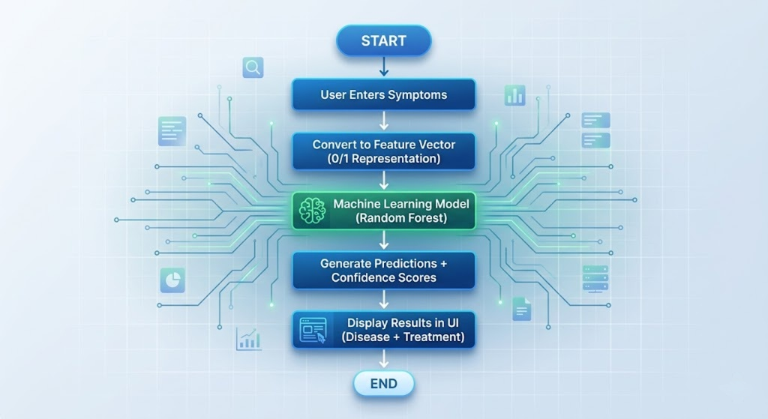

Tools and Technologies:
- Language: Python
- Libraries: Pandas, NumPy, Scikit-learn
- Framework: Streamlit
- Algorithm: Random Forest
User Interface:
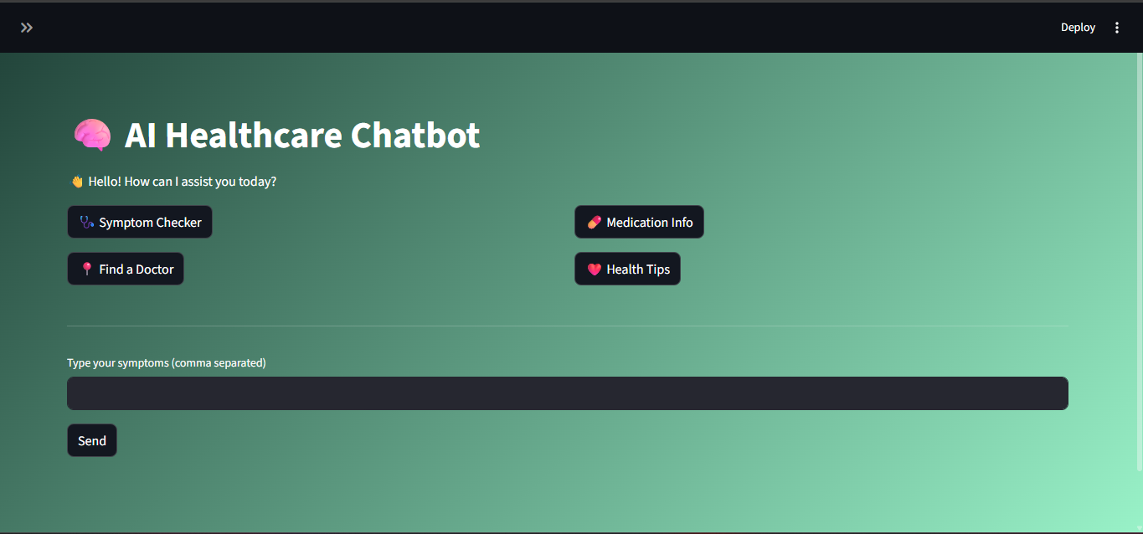
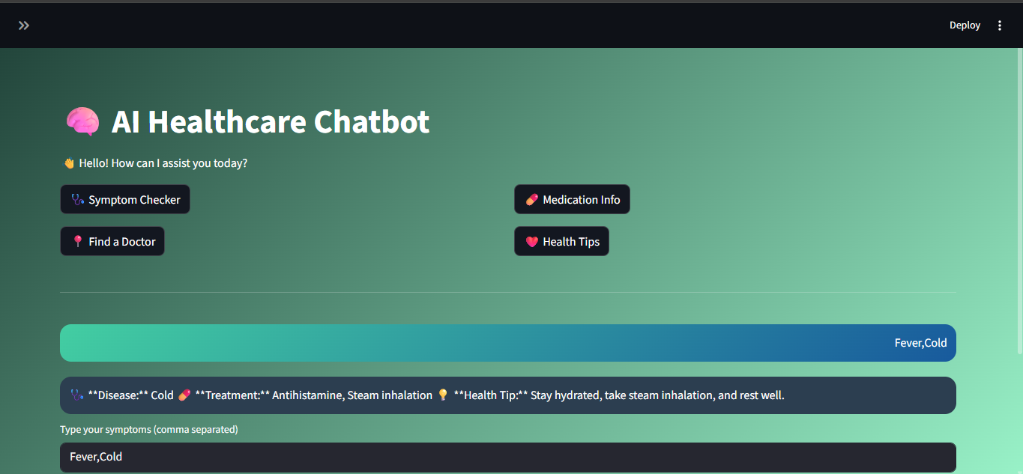
Results and Analysis:
Example:
Input:
headache, nausea
Output:
Migraine → 61%
Cold → 15%
Advantages and Disadvantages:
Advantages | Limitations
Fast and efficient | Limited dataset
Easy to use | Not a replacement for doctors
Supports early diagnosis | Accuracy depends on input
Accessible anywhere | Cannot handle complex medical conditions
Future Scope:
- Integration with real hospital data
- Voice-based assistant
- Mobile app development
- AI chatbot with NLP
- Integration with wearable devices
- Direct access with doctor’s instantly
- Medication info and order medicines instantly
- Regular Health tip’s notification

Conclusion:
The AI Healthcare Assistant demonstrates how machine learning can enhance healthcare accessibility. The system provides reliable predictions and a user-friendly interface, making it a valuable tool for preliminary diagnosis. With further improvements, it can evolve into a powerful healthcare support system.

References:
- Kaggle Datasets
- Scikit-learn Documentation
- Streamlit Documentation
- AI in Healthcare Research Papers

